

3 – Software Fundamental:

* A collection of instructions, data, or programs that allow computers to perform specific tasks.

**Types of software:**

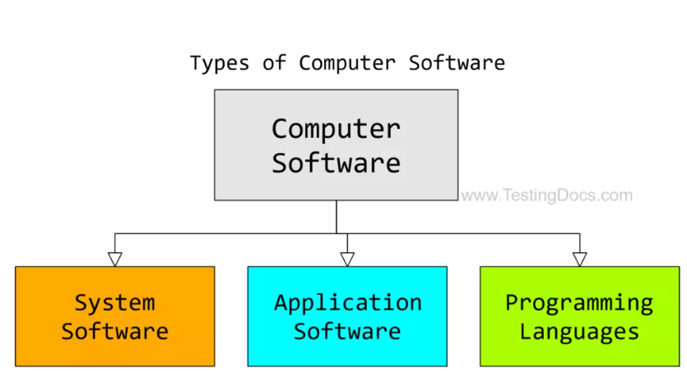



**System software:**

* A type of computer program that manages a computer’s hardware and application programs.

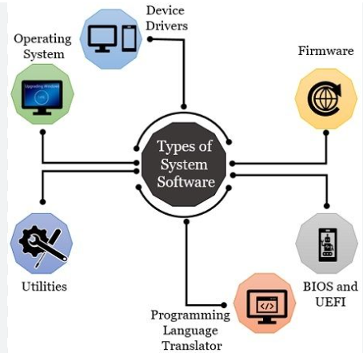



**Operating System:**

* A collection of software that manages computer hardware and provides services for programs. It acts as an interface between the hardware and user applications.

**Programming Language Translator:**

* Programming translators are the software that converts high-level language into machine language (0/1)

**Device Drivers:**

* Reduce the troubleshooting issues in the system

**Firmware Software:**

* These are the operational software installed on the computer motherboards that help the system to identify the Flash, ROM, EPROM, EEPROM, and memory chips.
* There are two main types of chips:

BIOS: Basic Input/ Output System chip

UEFI: Unified Extended Firmware Interface chips

**Utility Software:**

* It’s a part of Works as an interface between system software and application software. It’s a third-party tool designed to reduce maintenance issues and detect errors in the computer system.

**Utility Software:**

* Application software is a set of programs designed to perform a specific task. It does not control the working of the computer as it is designed for end-users.
* A computer can run without application software
* It can easily installed or uninstalled as required. It can be a single program or a collection of small programs
* E.g. Microsoft Office Suite, Adobe Photoshop





**Word Processing Software:**

* Text can be edited and formatted; documents, including memos, letters, faxes, and documents, are created using word processing software

**Spreadsheet Software:**

* Using a variety of tools, we can make calculations with the aid of a spreadsheet program. The information is arranged in rows and columns in a tabular manner. A cell is a point where a row and a column meet. Data, time, and number data are stored in these cells.

**Programming Software:**

* It is a set or collection of tools that help developers in writing other software or programs.
* It assists them in creating, debugging, and maintaining software or programs or applications. ----> IDE